Page
1. Creating a new Graduation Plan x
2. Loading a saved Graduation Plan x
3. Modifying a Graduation Plan x
3.1. Adding a Semester x
3.2. Modifying a Semester x
3.2.1. Adding a Course x
3.2.2. Removing a Course x
3.2.3. Modifying a Course x
3.2.3.1. Modify Grade x
3.2.3.2. Add a Comment x
4. Viewing a Graduation Plan x
4.1. Viewing Student Information x
4.2. Viewing Courses in a Semester x
4.3. Viewing Course Information x
4.4. Viewing Remaining Graduation Requirements x
5. Saving a Graduation Plan x
6. Printing a Graduation Plan x
7. Exiting the Quick Grad Planner x

1. Creating a new Graduation Plan.

Start the program.
When the program starts, the Welcome Screen is displayed, see Figure 1 below.

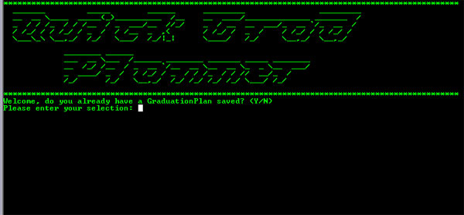
Figure 1, Welcome Screen

Enter ‘N’, to assert that you do not have a saved Graduation Plan file. A series of prompts will follow. Enter your first name, and then when prompted, then enter your last. A list of available programs at UMBC is displayed, choose one of them. See Figure 1-1.

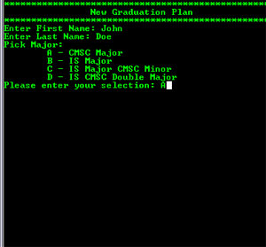
Figure 1-1, New User Setup Steps 1 & 2

Next the program will prompt you for a starting semester. First enter in the semester designator. The semester designators are FL, SP, WI, and SU for fall, spring, winter, and summer respectively. When prompted enter the year of the starting semester for the Graduation Plan, see Figure 1-2.

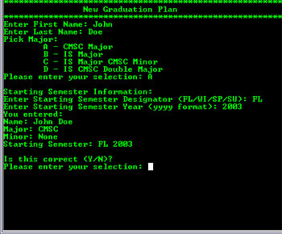
Figure 1-2, New User Setup Step 3

If the information entered is incorrect, enter ‘N’, else enter ‘Y’. If you entered ‘Y’ then your Graduation Plan has been created and the Main Menu is displayed, from which you can interact with your Graduation Plan, see Figure 3.

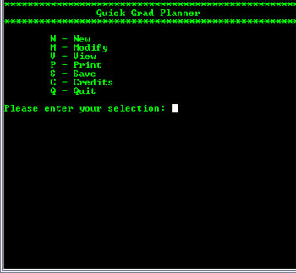
Figure 3, Main Menu

2. Loading a saved Graduation Plan

Start the program.
When the program starts, the Welcome Screen is displayed, see Figure 1 below.

Figure 1, Welcome Screen

Enter ‘Y’ to assert that you have a saved Graduation Plan which the program will then read in from the file: GraduationPlan.txt. The Main Menu is displayed, from which you can interact with your Graduation Plan, see Figure 3.

Figure 3, Main Menu

3. Modifying a Graduation Plan

From the Main Menu, see Figure 3 above, type ‘M’. This will bring up the Modify Menu, see Figure 3-1.

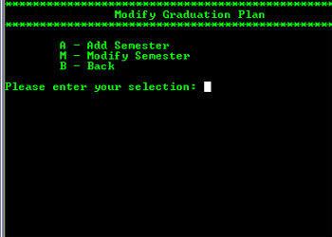
Figure 3-1, Modify Menu

From the Modify Menu you can add semesters, modify semesters, add and remove courses from semesters, and modify courses information.

3.1. Adding a Semester

From the Modify Menu, see Figure 3-1 above, type ‘A’. This will display a series of prompts requesting information regarding the semester addition. First enter the semester designator (FL=fall, SP=spring, WI=winter, SU=summer), then the semester year, see Figure 3-1-1.

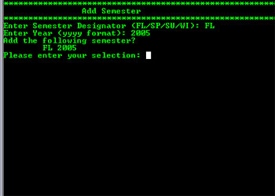
Figure 3-1-1, Semester Addition

Enter ‘Y’ to confirm addition of semester, or ‘N’ to reenter information. If the semester entered already exists, the program will not let you add a duplicate.

3.2. Modifying a Semester

From the Modify Menu, see Figure 3-1 above, type ‘M’. A list of semester in Graduation Plan is displayed; see Figure 4-2, Semester Selection Menu below. Select the semester you would like to modify and the Modify Semester Menu is displayed, see Figure 3-2-1.

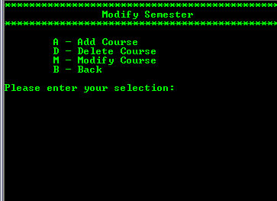
Figure 3-2-1, Modify Semester Menu

From the Modify Semester Menu you may add a course, delete a course from the semester, or modify a course’s information in the semester.

3.2.1. Adding a Course

From the Modify Semester Menu, see Figure 3-2-1 above, type ‘A’. A list of courses to add is displayed, see Figure 3-2-1-1. If you choose a course for which the prerequisites are not yet met the program will not allow this and inform you.

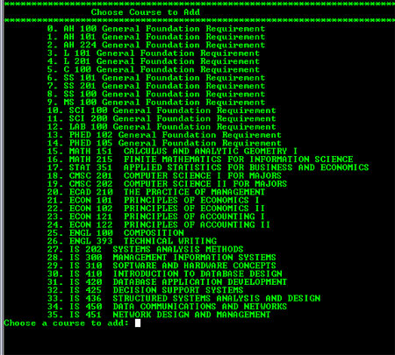
Figure 3-2-1-1 Courses to Add

Choose the course to add by typing the number to the left of the course, and confirm the addition by typing ‘Y’. Type ‘N’ to cancel. If you do not meet the prerequisites you will need to hit ‘B’ to return to the Modify Semester Menu, see Figure 3-2-1.

3.2.2. Removing a Course

From the Modify Semester Menu, see Figure 3-2-1 above, type ‘D’. The available courses in the semester to delete will be displayed, see Figure 4-3. Enter the number to the left of the course you would like to delete. To confirm deletion type ‘Y’ when prompted, else ‘N’ to cancel. Once the course is added you will return the Modify Semester Menu, see Figure 3-2-1.

3.2.3. Modifying a Course
From the Modify Semester Menu, see Figure 3-2-1 above, type ‘M’. The available courses in the semester to modify will be displayed, see Figure 4-3. Enter the number to the left of the course you would like to modify. The Modify Course Menu will be displayed, see Figure 3-2-3.

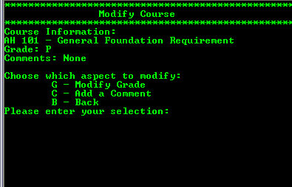
Figure 3-2-3, Modify Course Menu

From the Modify Course Menu you may modify the course’s grade or add a comment.

3.2.3.1. Modify Grade

From the Modify Course Menu, see Figure 3-2-3 above, type ‘G’. A prompt is displayed asking for a new grade; see Figure 3-2-3-1.

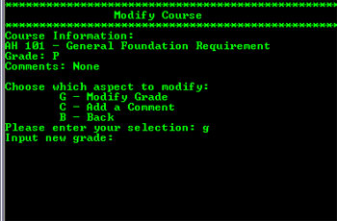
Figure 3-2-3-1, Input New Grade

Type the new grade and hit return. The same course will be displayed with the updated grade and the Modify Course Menu. Type ‘B’ to return the Modify Semester Menu, see Figure 3-2-1.

3.2.3.2. Add a Comment

From the Modify Course Menu, see Figure 3-2-3 above, type ‘C’. You will be prompted to enter in comments, spaces are allowed. Warning this will override any comments currently stored in the course’s information. See figure 3-2-3-2.

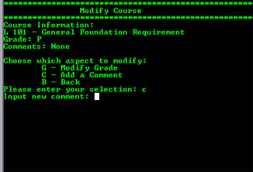
Figure 3-2-3-2, Input New Comments

Type the comments and hit return. The same course will be displayed with the updated grade and the Modify Course Menu. Type ‘B’ to return the Modify Semester Menu, see Figure 3-2-1.

4. Viewing a Graduation Plan

From the Main Menu, see Figure 3 above, type ‘V’. A new menu will be displayed with options pertaining to viewing a Graduation Plan, see Figure 4.

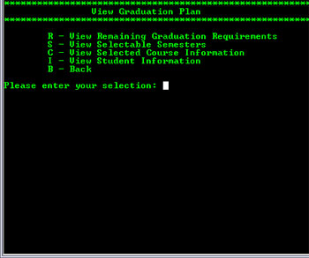
Figure 4, View Menu

4.1. Viewing Student Information

From the View Menu, see Figure 4 above, type ‘I’. The student information for the Graduation Plan will be displayed on the screen, see Figure 4-1.

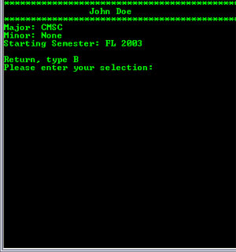
Figure 4-1, Student Information

Press ‘B’ to return to the View Menu.

4.2. Viewing Courses in a Semester

From the View Menu, see Figure 4 above, type ‘S’. A list of semesters currently stored in the Graduation Plan is displayed, see Figure 4-2. Enter in the number to the left of the semester you would like to view.

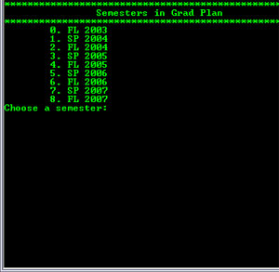
Figure 4-2, Semester Selection Menu

Once a semester is selected a list of courses under that semester are displayed, see Figure 4-2-1. To return to the View Menu, type ‘B’.

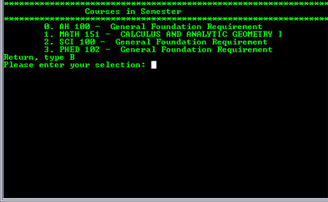
Figure 4-2-1, Semester Course List

4.3. Viewing Course Information

From the View Menu, see Figure 4 above, type ‘C’. A semester selection menu will be displayed, see Figure 4-2 above. Chose the semester in which the course you’d like to view is located. A list of Courses in the chosen semester is displayed, see Figure 4-3.

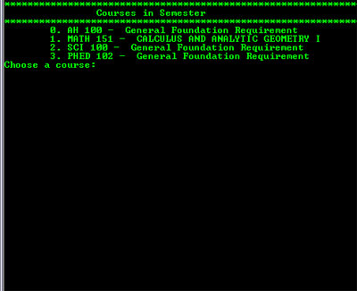
Figure 4-3, Course Selection Menu

Select the course you would like to view by typing the number to the left of the course. The information for that course is displayed; see Figure 4-3-1.

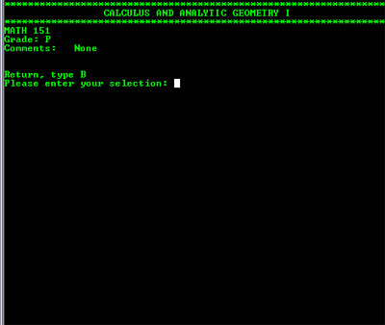
Figure 4-3-1, Course Information

Type ‘B’ to return to the View Menu.

4.4. Viewing Remaining Graduation Requirements

From the View Menu, see Figure 4 above, type ‘R’. Displayed will be a list of all courses remaining which are required to graduate with the selected Major/Minor, see Figure 4-4.

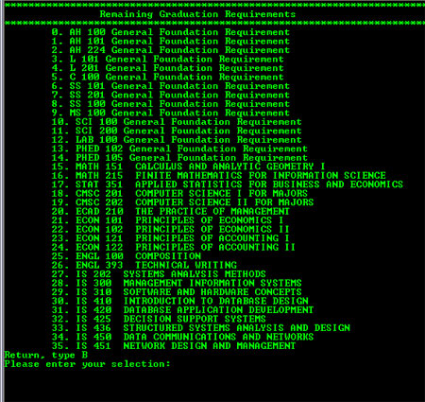
Figure 4-4, Remaining Graduation Requirements

5. Saving a Graduation Plan

From the Main Menu, see Figure 3 above, type ‘S’. The Main Menu will flash and a file is created in the program’s directory. This file is named: GraduationPlan.txt. The program will use this file as input next time the program is run. The program also prompts to save upon exit. Hit ‘Y’ to save again, overwriting the most recent saved version of the Graduation Plan, or ‘N’ to exit, see Figure 5.

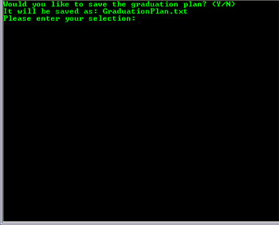
Figure 5, Save upon exit

6. Printing a Graduation Plan

From the Main Menu, see Figure 3 above, type ‘P’. The Main Menu will flash and a file is created in the program’s directory. This file is named: PrintableGraduationPlan.txt. Open this file in a preferred word processor and send it to printer.

7. Exiting the Quick Grad Planner

From the Main Menu, see Figure 3 above, type ‘Q’. You will be prompted to save your Graduation Plan. To save type ‘Y’, or type ‘N’ to exit without saving changes. See Figure 5 above.

